Electronic supplementary information

**Synthesis and properties of nOVEL  
arylamine derivatives oF  
benzothieno[3,2-b][1]benzothiophene**

E. A. Bobrova,*a,b* O. V. Borshchev,\**a* N. M. Surin,*a* and S. A. Ponomarenko*a*

a Enikolopov Institute of Synthetic Polymeric Materials, Russian Academy of Sciences,

ul. Profsoyuznaya 70, Moscow, 117393 Russia

b Moscow Institute of Physics and Technology (National Research University),

Institutskiy per. 9, Dolgoprudny, Moscow Oblast, 141700 Russia

**Table of contents**

Syntheses S2

Procedures for the synthesis of (DPA)2BTBT S2

Procedures for the synthesis of (NPA)2BTBT S2

Procedures for the synthesis of (NTPDA)2BTBT S3

NMR spectra for the synthesized compounds S5

1H NMR spectrum of (DPA)2BTBT S5

1H NMR spectrum of (NPA)2BTBT S5

1H NMR spectrum of *N'*-1-naphthyl-*N,N*-diphenylbenzene-1,4-diamine S6

1H NMR spectrum of (NTPDA)2BTBT S6

GPC for the synthesized compounds S7

GPC of (DPA)2BTBT S7

GPC of (NPA)2BTBT S8

GPC of (NTPDA)2BTBT S9

DSC for the synthesized compounds S10

DSC of (DPA)2BTBT S10

DSC of (NPA)2BTBT S10

DSC of (NTPDA)2BTBT S11

TGA of (DPA)2BTBT, (NPA)2BTBT, (NTPDA)2BTBT S12

Optical properties S13

References S15

# Syntheses

## Procedures for the synthesis of (DPA)2BTBT



This method was based on the literature procedure [1]. 29 mg (0.00005 mol) of Pd(dba)2 and 50 mg (0.00025) of *t*Bu3P were added to a stirred solution of 1.2751 g (0.00754 mol) of *N*-phenylaniline [1], 0.5626 g (0.00502 mol) of potassium *tert*-butoxide, and 1 g (0.00251 mol) of BTBT-Br2 [2] in anhydrous toluene (50 mL) at 100 °C (oil bath temperature 115 °C) under an argon atmosphere for 15 h. Toluene was removed under reduced pressure. The product was isolated by passing the resulting mixture through a layer of silica gel in toluene. The crude product was purified by recrystallization from toluene to give the target product as a yellow powder (1.3 g, 92%). 1H NMR (250 MHz, benzene-d): 7.00–7.08 (m, 4H, Ph), 7.10–7.19 (t, 12H, Ph, *J* =7.9 Hz), 7.20–7.23 (m, 2H, BTBT), 7.27–7.39 (d, 4H, Ph, *J* =8.2 Hz), 7.52–7.55 (d, 2H, BTBT, *J* =1.8 Hz), 7.62–7.70 (d, 2H, BTBT, *J* =8.5 Hz). Anal. Calcd. for C38H26N2S2: C, 79.41; H, 4.56; N, 4.87; S, 11.16. Found: C, 79.76; H, 4.51; N, 4.90; S, 11.21%. MS-MALDI (m/z): [M]+ calcd for (C38H26N2S2) 574.1532, found 574.1517.

## Procedures for the synthesis of (NPA)2BTBT



29 mg (0.00005 mol) of Pd(dba)2 and 50 mg (0.00025) of *t*Bu3P were added to a stirred solution of 1.6523 g (0,00754 mol) of *N*-phenylnaphthalene-1-amine [3], 0.5626 g (0.00502 mol) of potassium *tert*-butoxide and 1 g (0.00251 mol) of BTBT-Br2 [2] in anhydrous toluene (50 mL) at 100 °C (oil bath temperature 115°C) under an argon atmosphere for 7 h. Toluene was removed under reduced pressure. The product was isolated by passing the resulting mixture through a layer of silica gel in toluene. The crude product was purified by column chromatography (eluent: toluene/cyclohexane, 1:3) to give the target compound as a yellow powder (1.1 g, 63%). 1H NMR (250 MHz, benzene-d): 6.74–6.84 (m, 2H, Ph), 6.94–6.99 (m, 10 H, Napht), 7.02–7.05 (m, 4H, Napht), 7.07–7.15 (m, 4H, BTBT), 7.16–7.21 (d, 2H, Ph, *J* =8.5 Hz), 7.48–7.55(m, 4H, Ph), 7.59–7.66 (d, 2H, Ph, *J* =8.5 Hz), 8.09–8.16 (d, 2H, BTBT, *J* =8.2 Hz). Anal. Calcd. for C46H30N2S2: C, 81.87; H, 4.48; N, 4.15; S, 9.50. Found: C, 81.74; H, 4.49; N, 4.13; S, 9.61%. MS-MALDI (m/z): [M]+ calcd for (C46H30N2S2) 674.1845, found 674.1837.

## Procedures for the synthesis of (NTPDA)2BTBT

***N'*-1-Naphthyl-*N,N*-diphenylbenzene-1,4-diamine**



The synthesis was carried out according to the published procedure [4]. 308 mg (0.0005 mol) of Pd(dba)2 and 217 mg (0.001 mol) of *t*Bu3P was added to a stirred solution of 17.4 g (0.054 mol) of 4-bromo-*N,N*-diphenylaniline [5], 6 g (0.054 mol) of potassium *tert*-butoxide and 23 g (0.16 mol) of 1-naphthylamine in anhydrous toluene (500 mL) at 100 °C (oil bath temperature 115 °C) under an argon atmosphere for 6 h. Toluene was removed under reduced pressure. The product was isolate by passing the reaction mixture through a layer of silica gel in toluene. The crude product was purified by column chromatography (eluent: toluene/cyclohexane, 1:3) to give pure compound as a yellow powder (12.4 g, 60%). 1H NMR (250 MHz, benzene-d): 7.82–7.76 (m, 1H, Ph), 7.70–7.63 (m, 1H, Ph), 7.38–7.44 (dd, 1H, Ph, *J* = 7.3, 1.8 Hz), 7.35–7.27 (ddd, 1H, Ph, *J* = 8.2, 6.8, 1.5 Hz), 7.26–7.15 (m, 7H, Napht), 7.13–7.04 (m, 4H, Ph), 7.01–6.95 (m, 2H, Ph), 6.89–6.76 (m, 2H, Ph), 6.71–6.58 (m, 2H, Ph), 5.29 (s, 1H, NH).

**(NTPDA)2BTBT**



29 mg (0.00005 mol) of Pd(dba)2 and 50 mg (0.00025) of *t*Bu3P was added to a stirred solution of 2.9123 g (0.00754 mol) of *N'*-1-naphthyl-*N,N*-diphenylbenzene-1,4-diamine, 0.5626 g (0.00502 mol) of potassium *tert*-butoxide and 1 g (0.00251 mol) of BTBT-Br2 [2] in anhydrous toluene (50 mL) at 100 °C (oil bath temperature 115 °C) under an argon atmosphere for 7 h. Toluene was removed under reduced pressure. The product was separated by passing the reaction mixture through a layer of silica gel in toluene. The crude product was purified by column chromatography (toluene/cyclohexane, 1:3) to give the target compound as a yellow powder (1.4 g, 54%). 1H NMR (250 MHz, benzene-d): 6.75–6.85 (t, 4H, Ph, *J* =7.1 Hz), 6.88–6.95 (s, 8H, Ph), 6.97–7.07 (m, 8H, Napht), 7.08–7.12(m, 16H, Ph), 7.18–7.28 (m, 6H, Napht), 7.48–7.56 (d, 4H, BTBT, *J* = 11.6 Hz), 7.60–7.66 (d, 2H, BTBT, *J* = 9.2, 2.1 Hz), 8.12–8.22 (dd, 2H, Napht, *J* = 9.2, 2.1 Hz). Anal. Calcd. for C70H48N4S2: C, 79.41; H, 4.56; N, 4.87; S, 11.16. Found: C, 79.50; H, 4.59; N, 4.84; S, 11.21%.

MS-MALDI (m/z): [M]+ calcd for (C70H48N4S2) 1008.3315, found 1008.3301.

# NMR spectra for the synthesized compounds

The 1H NMR spectra were recorded on a Bruker WM-250 NMR spectrometer (Germany) at 250.13 MHz. The chemical shifts were referenced to the solvent signals.

## 1H NMR spectrum of (DPA)2BTBT

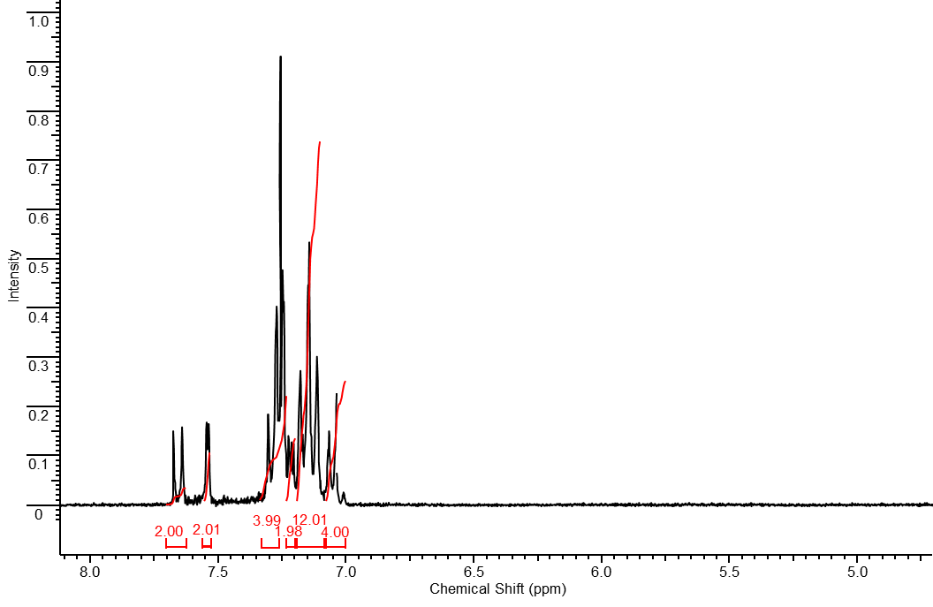

## 1H NMR spectrum of (NPA)2BTBT

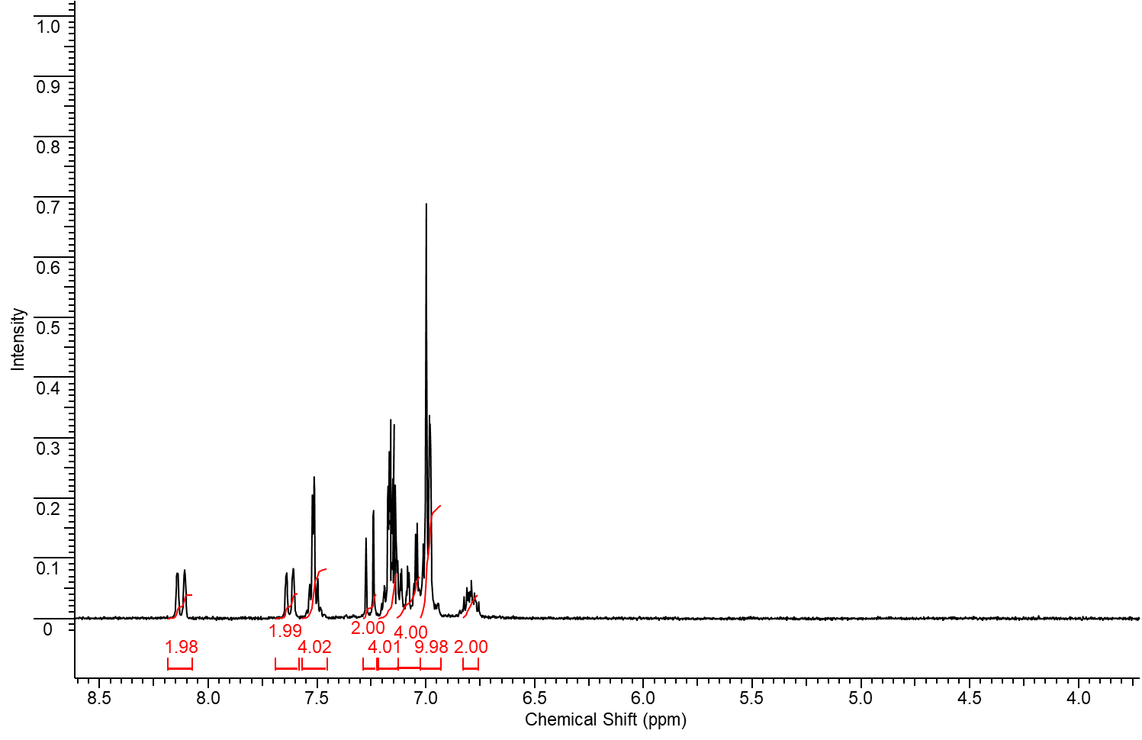

## 1H NMR spectrum of *N'*-1-naphthyl-*N,N*-diphenylbenzene-1,4-diamine

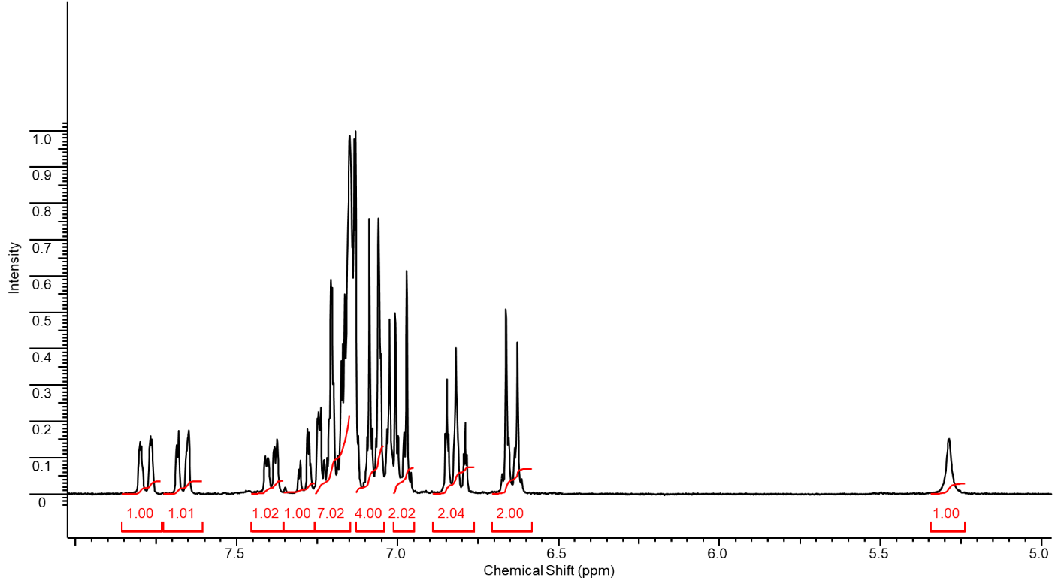

## 1H NMR spectrum of (NTPDA)2BTBT

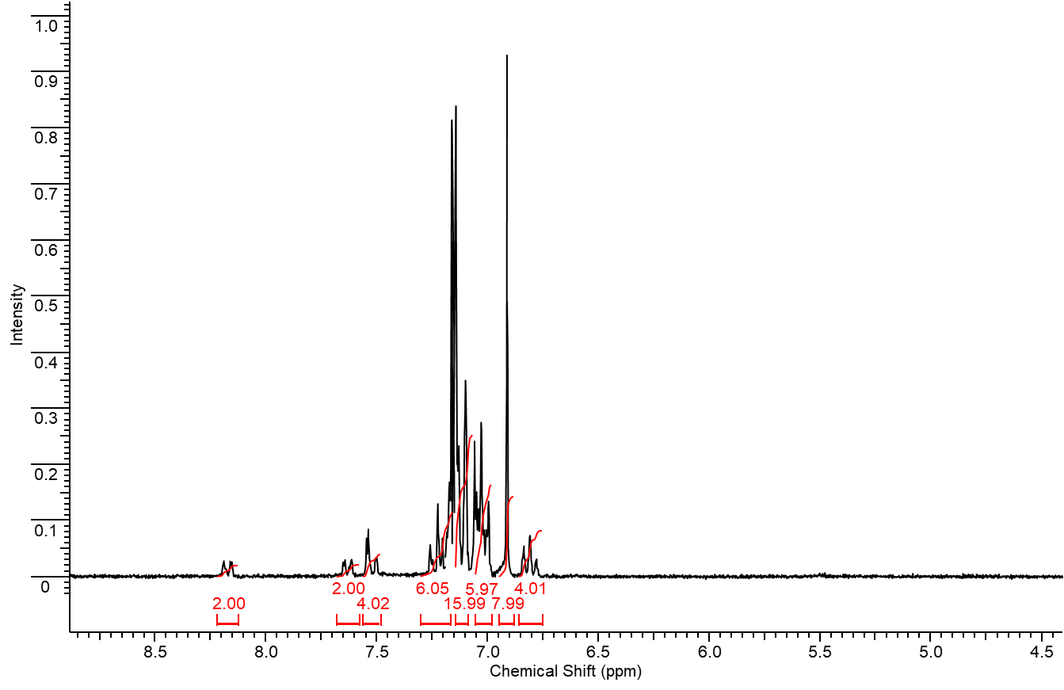

# GPC for the synthesized compounds

The GPC analysis was performed on a Shimadzu instrument equipped with a RID10AVP refractometer and an SPD-M10AVP diode matrix as detectors using 7.8 × 300 mm2 Phenomenex columns (USA) filled with Phenogel sorbent with the pore size of 500 Å and THF as an eluent.

## GPC of (DPA)2BTBT

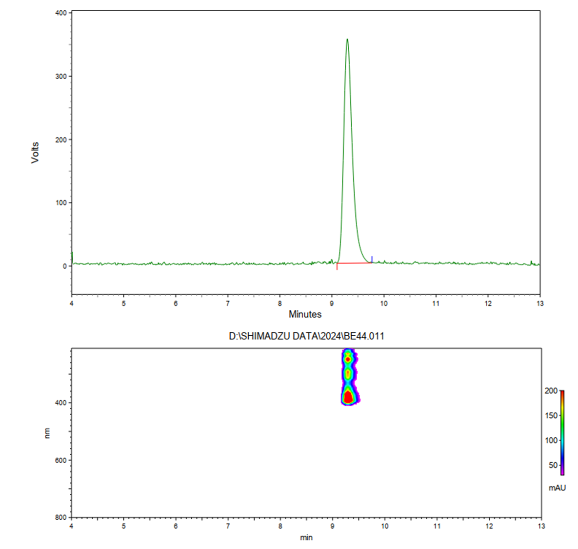

## GPC of (NPA)2BTBT

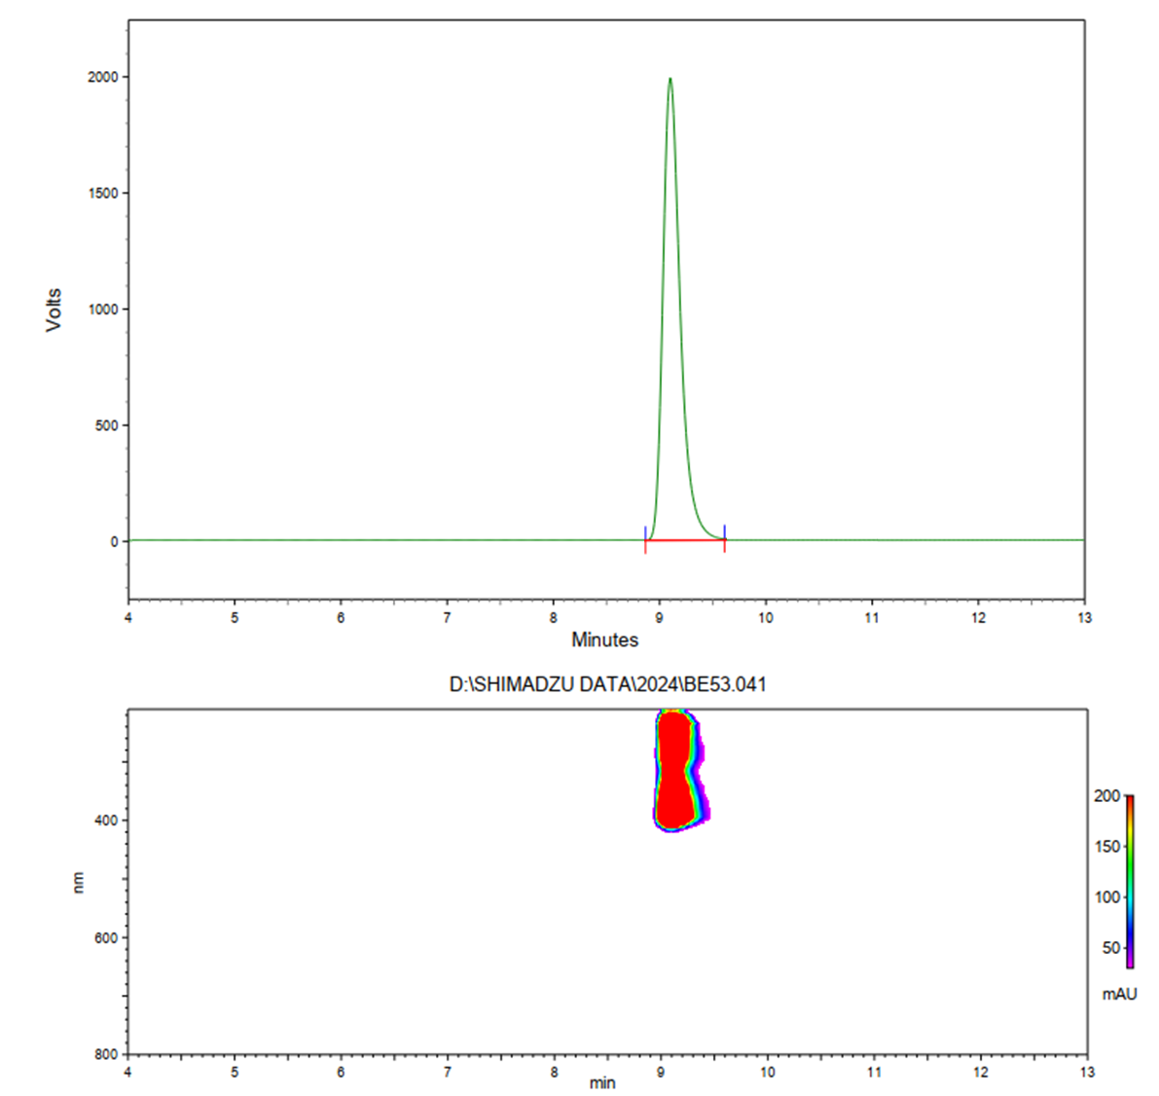

## GPC of (NTPDA)2BTBT

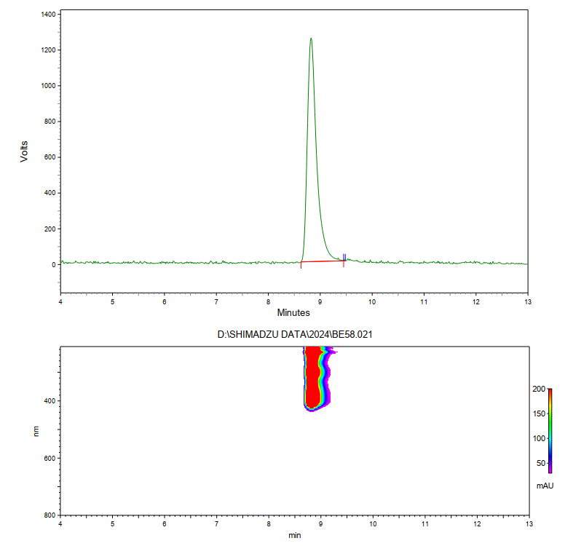

# DSC for the synthesized compounds

The DSC curves were recorded on a Perkin-Elmer DSC7 differential scanning calorimeter (Germany) in the temperature range from 40 to 350 °C under an argon atmosphere.

## DSC of (DPA)2BTBT

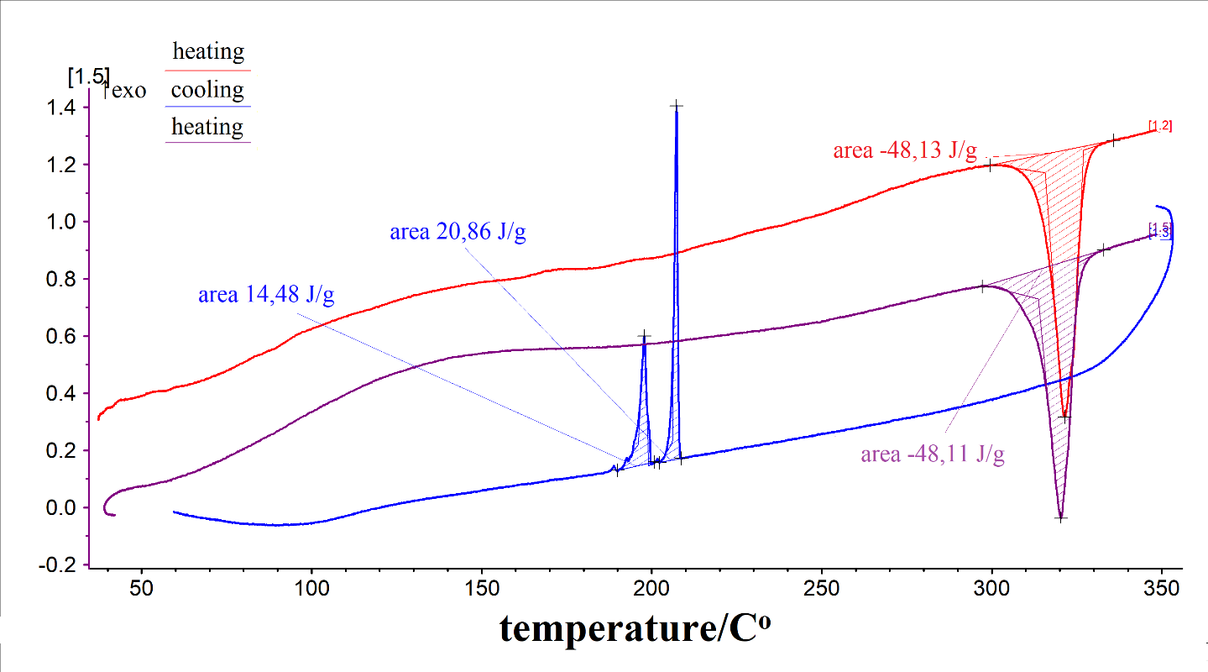

## DSC of (NPA)2BTBT

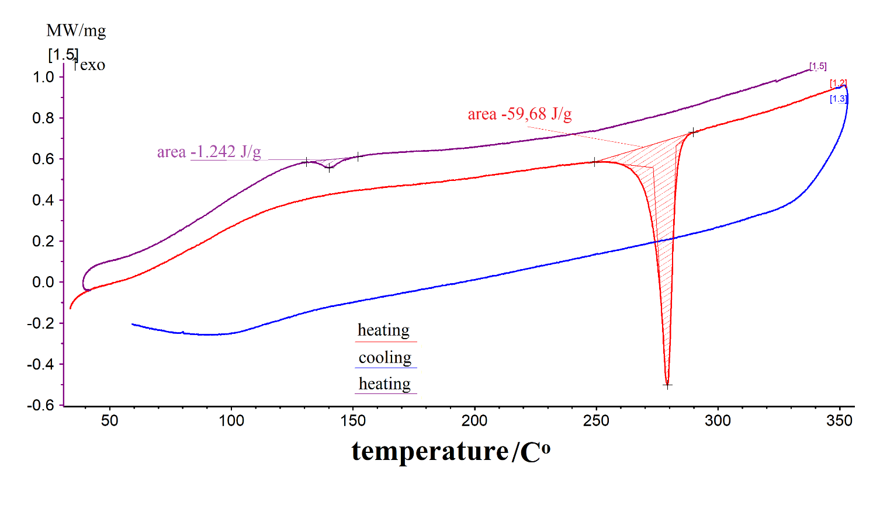

## 

## DSC of (NTPDA)2BTBT

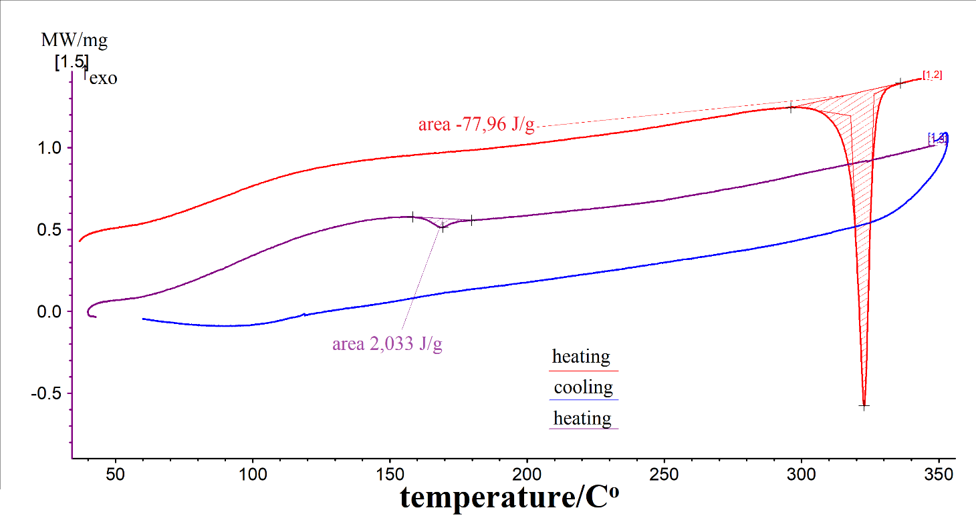

# TGA of (DPA)2BTBT, (NPA)2BTBT, and (NTPDA)2BTBT

The TGA curves were recorded on a NETZSCH STA JUPITER 443 F3 instrument (Germany) in the temperature range from 40 to 700 °C.

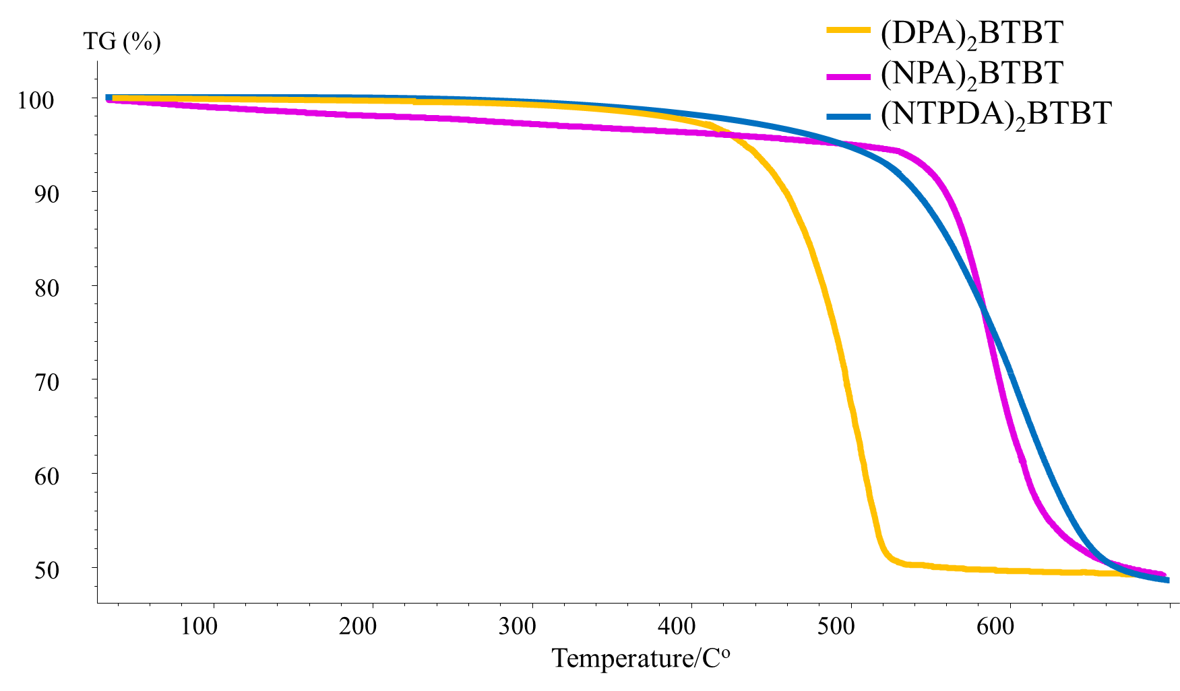

# Optical properties

The absorption spectra of THF solutions of the compounds explored were measured with a Shimadzu UV-2501PC spectrophotometer (Japan). The standard 10×10 quartz cuvettes were used to measure the luminescence spectra of the solutions. The quantum yields were determined relative to the known quantum yields of the standards used for measuring the fluorescence of optically dilute solutions. A solution of *p*-terphenyl in cyclohexane (*ϕ* = 0.91) was used as a standard for measuring the quantum yields.







# 

# References

1. J. F. Hartwig, M. Kawatsura, S. I. Hauck, K. H. Shaughnessy, L. M. Alcazar-Roman, *J. Org. Chem*., **1999**, *64*, 5575–5580. DOI: 10.1021/jo990408i

2. M. S. Polinskaya, A. A. Trul, O. V. Borshchev, M. S. Skorotetcky, V. P. Gaidarzhi, S. K. Toirov, D. S. Anisimov, A. V. Bakirov, S. N. Chvalun, E. V. Agina, S. A. Ponomarenko, *J. Mater. Chem. C*, **2023**, *11*, 1937–1948. DOI: 10.1039/D2TC05083H

3. M. A. Topchiy, P. B. Dzhevakov, M. S. Rubina, O. S. Morozov, A. F. Asachenko, M. S. Nechaev, *Eur. J. Org. Chem*., **2016**, 1908–1914. DOI: 10.1002/ejoc.201501616

4. Patent KR20130086757A, C07C211/50; C07C211/54; H01L51/50, **2013**.

5. S. Nad, S. Malik, *ChemElectroChem*, **2020**, *7*, 4144–4152. DOI: 10.1002/celc.202001114